PROGRAM-5

1. Problem Statement
Text compression is a technique used to reduce the length of a string by grouping consecutive repeated characters. In this case study, a Python program is developed to encode a string by counting consecutive repeated characters. The program compares the length of the original string with the encoded string and determines whether compression is beneficial. If the encoded string is shorter than the original string, compression is considered beneficial; otherwise, it is not beneficial.
2. Objectives
- To understand the concept of text compression.
- To encode a string by grouping consecutive repeated characters.
- To count the occurrences of consecutive characters.
- To calculate the original and encoded string lengths.
- To compare both lengths and determine whether compression is beneficial.
3. Assumptions
- The input is a string entered by the user.
- Only consecutive repeated characters are grouped.
- Each character is represented by the character followed by its count.
- Characters that occur only once are also represented with a count of 1.
- Compression is beneficial only when the encoded string is shorter than the original string.
- The program uses basic Python concepts such as strings, variables, loops, and conditional statements.
4. Algorithm
- Start.
- Read a string from the user.
- Calculate the length of the original string.
- Initialize an empty encoded string and set the index to zero.
- Count consecutive repeated characters using a loop.
- Append each character and its count to the encoded string.
- Calculate the length of the encoded string.
- Display the original string, encoded string, and their lengths.
- Compare both lengths.
- If the encoded length is smaller, display “Compression is beneficial”; otherwise, display “Compression is not beneficial.”
- Stop
5.flowchart
  - Flowchar
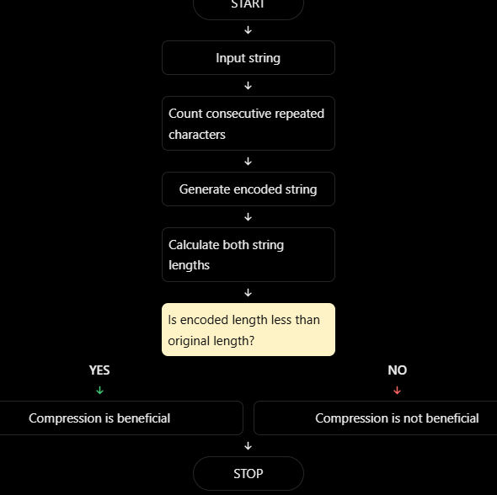

6.pseudocode
START

Read a string from the user

Set original_length = length of the string
Set encoded = empty string
Set i = 0

WHILE i is less than the length of the string
Set count = 1

WHILE the next character exists AND
current character equals next character
Increase count by 1
Increase i by 1
END WHILE

Add current character and count to encoded
Increase i by 1
END WHILE

Set encoded_length = length of encoded

Display original string
Display encoded string
Display original length
Display encoded length

IF encoded_length is less than original_length THEN
Display "Compression is beneficial"
ELSE
Display "Compression is not beneficial"
END IF

STOP

7.Python Source Code
text = input("Enter a string: ")

original_length = len(text)
encoded = ""
i = 0

while i < len(text):
count = 1

while i + 1 < len(text) and text[i] == text[i + 1]:
count += 1
i += 1

encoded += text[i] + str(count)
i += 1

encoded_length = len(encoded)

print("Original string:", text)
print("Encoded string:", encoded)
print("Original length:", original_length)
print("Encoded length:", encoded_length)

if encoded_length < original_length:
print("Compression is beneficial")
else:
print("Compression is not beneficial")
8.test cases

Test case | Input string | Encoded string | Original length | Encoded length | Expected result
1 | AAAABBBCCDA | A4B3C2D1A1 | 11 | 10 | Beneficial
2 | ABC | A1B1C1 | 3 | 6 | Not beneficial
3 | AAAAAA | A6 | 6 | 2 | Beneficial
4 | AABB | A2B2 | 4 | 4 | Not beneficial
5 | Empty string | Empty string | 0 | 0 | Not beneficial
9.output

Enter a string: AAAABBBCCDA
Original String: AAAABBBCCDA
Encoded String: A4B3C2D1A1
Original Length: 11
Encoded Length: 10
Compression is beneficial

10. Conclusion

Thus, the Python program successfully compresses a string by grouping consecutive repeated characters and counting their occurrences. It calculates the original and encoded string lengths and compares them to determine whether compression is beneficial. This case study demonstrates the use of strings, loops, variables, and conditional statements in Python.

